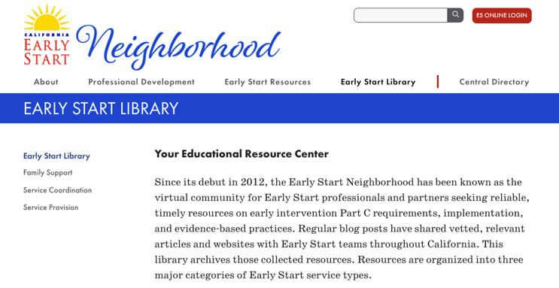
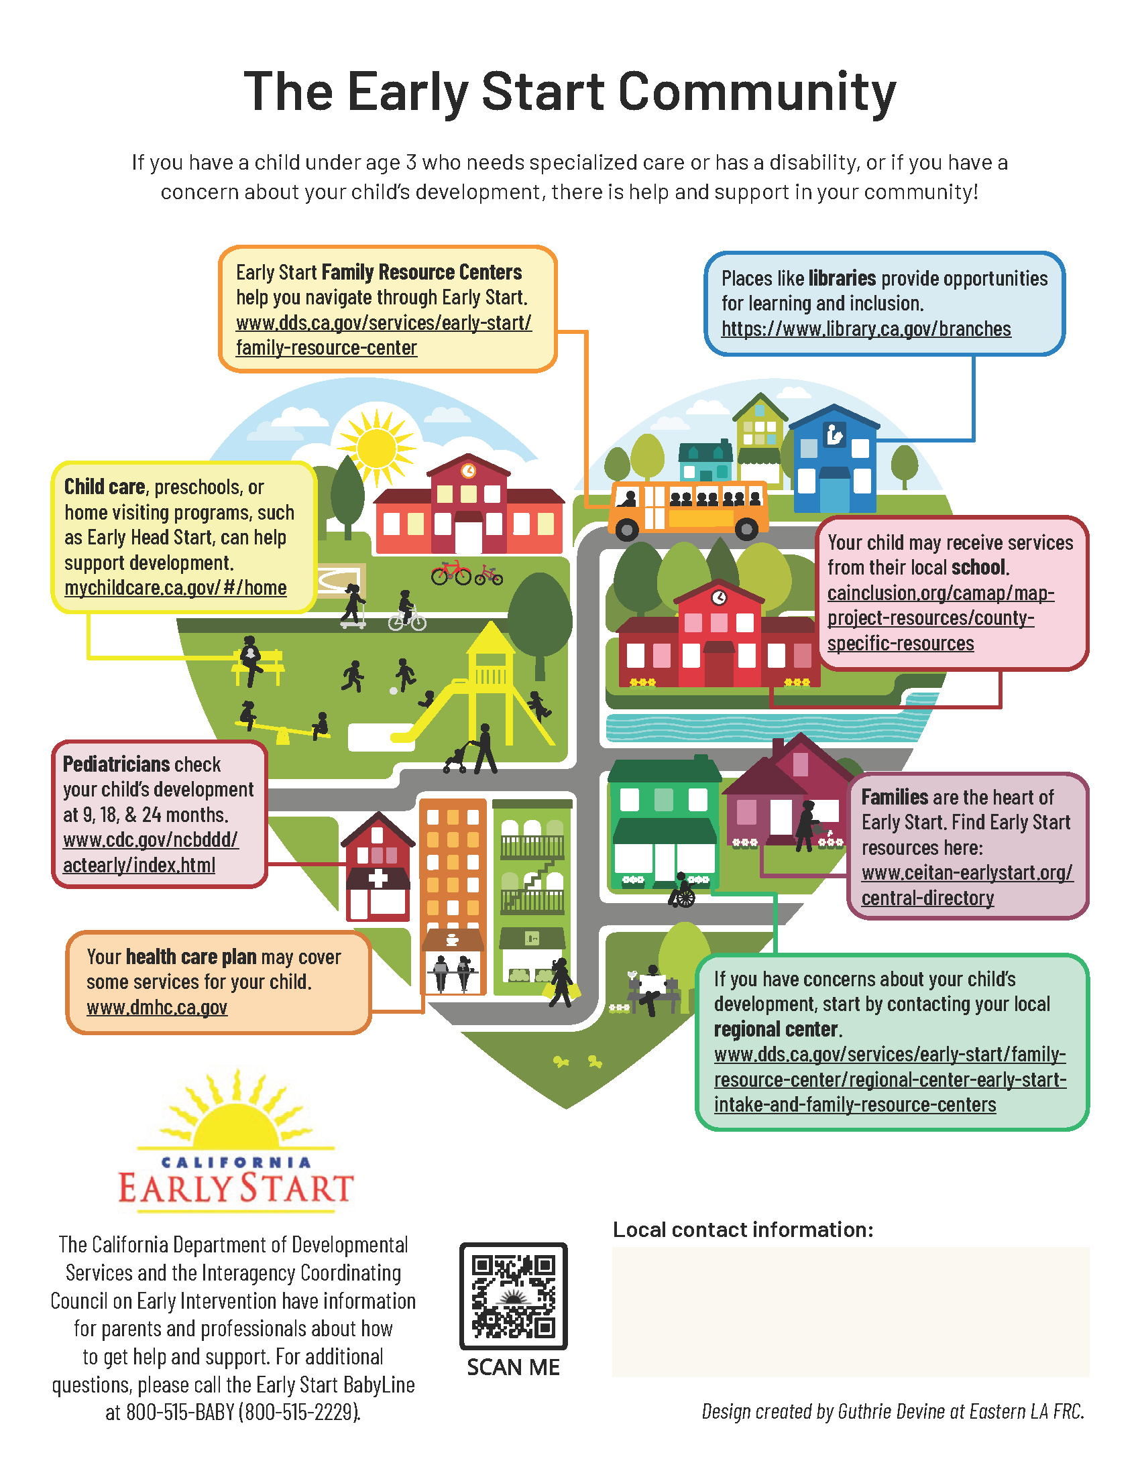
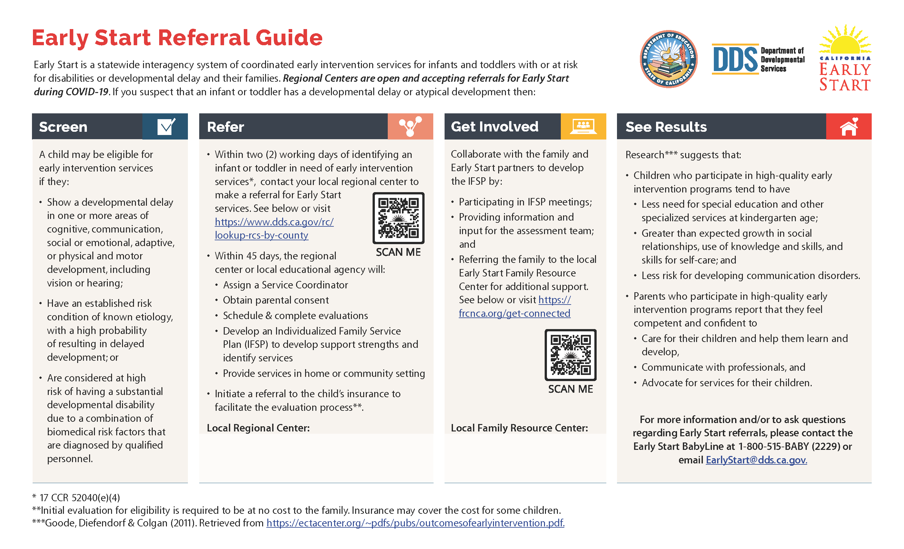
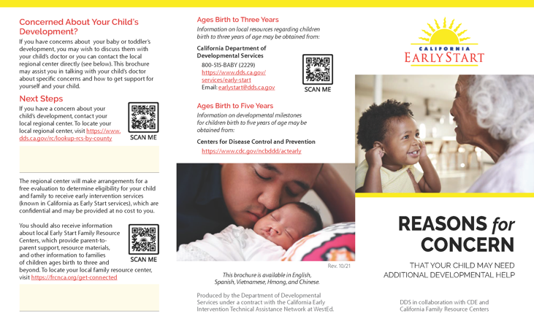

California Early Start
Outreach Resources Toolkit
Media & Communications Toolkit for the Use of
Early Start Outreach Products

This guide was prepared under Contract HD 229006, from the California Department of Developmental Services (DDS). The content does not necessarily reflect the views or policies of DDS, nor does mention of trade names, commercial products, or organizations imply endorsement by the State of California.

Table of Contents
About This Toolkit 4
Outreach Products 5
Early Start Community Infographic [poster] 5
Early Start Community Infographic [handout] 7
Early Start Family Resource Center Guide 9
Reasons for Concern Brochure 11
A Family Introduction to California Early Start 13
Early Start Referral Guide (Reasons to Refer) 15
“The Story of Max” Animated Video 16
Early Start Public Service Announcement (PSA) Videos 18
Additional Resources 20
Neighborhood Blog Posts 20
Calendar of Awareness Campaigns 21
Contact Information 26

About This Toolkit

This toolkit was designed to provide California Early Start (IDEA Part C early intervention) agencies and community partners with the guidance, foundational messaging, materials, and media to execute awareness and outreach efforts for the Early Start program within local communities throughout the state. The State-produced materials included in this guide are available for ordering, download, or embedding on Early Start partner agency websites and at no cost.
What’s Included in This Toolkit?
- Descriptions of each of the Early Start products available.
- Links to PDF resources for download or ordering in printed hard copies.
- Media links or embed codes to Early Start public service video and audio recordings.
- Instructions or advice for use of individual products.
How to Access the Print Resources and Place an Order
All resources intended for print in this toolkit are available to order in hard copy and/or for download at https://earlystartneighborhood.org/resources/resources-for-outreach-child-find-and-education/outreach-and-child-find-materials/. There is no charge for ordering materials. The cart method for ordering, provided on the website, allows tracking of requests and inventory and generates data related to local outreach efforts and needs. All printed materials are available in English and Spanish versions; additional language options vary across resources and formats.
How to Access and Obtain Video Resources
Video resources are accessible through a securely maintained video platform, Vimeo. The optimal strategy for disseminating the videos is to use the embed codes provided. Embedding the video from the private Vimeo account 1) preserves captioning choices that are a function of the video platform, 2) avoids redirection and ad placement that may occur for viewers if the video is placed on YouTube, and 3) generates data that facilitates annual reporting to the Office of Special Education Programs (OSEP) about Early Start outreach activities. Video resources may also be shared on social media outlets or downloaded for showing on personal computers. Instructions for embedding, sharing, and downloading are included on appropriate resource pages.
Questions?
For questions or technical concerns about the resources provided in this toolkit, please contact esorders@wested.org for assistance.

Outreach Products

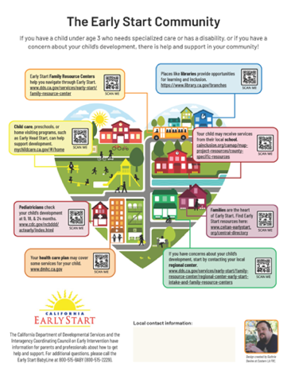
Early Start Community Infographic [poster]

Description: This resource presents Early Start within the context of other service systems. In addition to links to information about Early Start, the resource provides links to other agencies that provide services to young children and their families in communities throughout California.

Format: Large format (17 x 22 in.), full-color poster with QR codes linking to agency websites to provide the viewer with additional information about each service area/system shown.

Who should receive this resource: Operators of locations where parents and children congregate, as listed below.
Where to distribute this resource:
- Health care waiting rooms
- Childcare centers
- School communal areas
- Other public service agency office waiting areas (e.g., Social Security, WIC, Unemployment, DMV)
- Retail and restaurant locations (may be displayed on bulletin boards and in windows)
- Transportation hubs
- Libraries, fitness centers, and other public spaces where families may congregate
Before distributing this resource:
- Add agency contact information to the space in the bottom right-hand corner of the poster:
  - Write in the agency name, website address, phone number, and/or name of a contact person; or
  - Affix a label with the agency name, website address, phone number, and/or contact person’s name in the space provided; or
  - Use a pre-made rubber stamp to print the agency name, website address, phone number, and/or contact person’s name in the space provided.
- Use a QR code generator (online) to produce a QR code unique to your agency that may be printed on labels and affixed to the poster in the ‘Local contact information’ space so that viewers may scan the code to access your website.

Available language versions:
- Printed: English and Spanish
- Downloadable PDF: English and Spanish
Click on this link to order either Print or Digital Versions

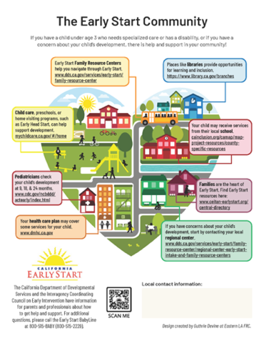
Early Start Community Infographic [handout]

Description: This resource presents Early Start within the context of other service systems. In addition to links to information about Early Start, the resource provides links to other agencies that provide services to young children and their families in communities throughout California.

Format: Letter-sized (8 ½ x 11 in.), full-color handout with QR codes linking to agency web sites to provide viewer with additional information about each service area/system shown.
Who should receive this resource: Parents and other primary caregivers of very young children.
Where to distribute this resource:
- Community resource and information fairs
- Health care waiting rooms, childcare centers
- Other public service agency office waiting areas (e.g., Social Security, WIC, Unemployment, DMV)
- Bulletin boards and windows in retail and restaurant locations
- Libraries, fitness centers, and other public spaces where families may congregate
- As attachments to emails to families
- As a page in a PDF newsletter or other publication
- As a downloadable resource on an agency website
Before distributing this resource:
- Add an agency website and phone number in the space in the lower right-hand corner:
  - Click on the form field in the PDF and type in the agency name, website address, phone number, and/or the name of a contact person; or
  - Affix a label with the agency name, website address, phone number, and/or contact person’s name in the space provided; or
  - Use a pre-made rubber stamp to print the agency name, website address, phone number, and/or contact person’s name in the space provided.
Available language versions:
- Printed: English, Spanish and Chinese
- Downloadable PDF: English, Spanish, Arabic, Armenian, Chinese, Farsi, Hmong, Korean, Russian, Tagalog, Vietnamese
Click on this link to order either Print or Digital Versions

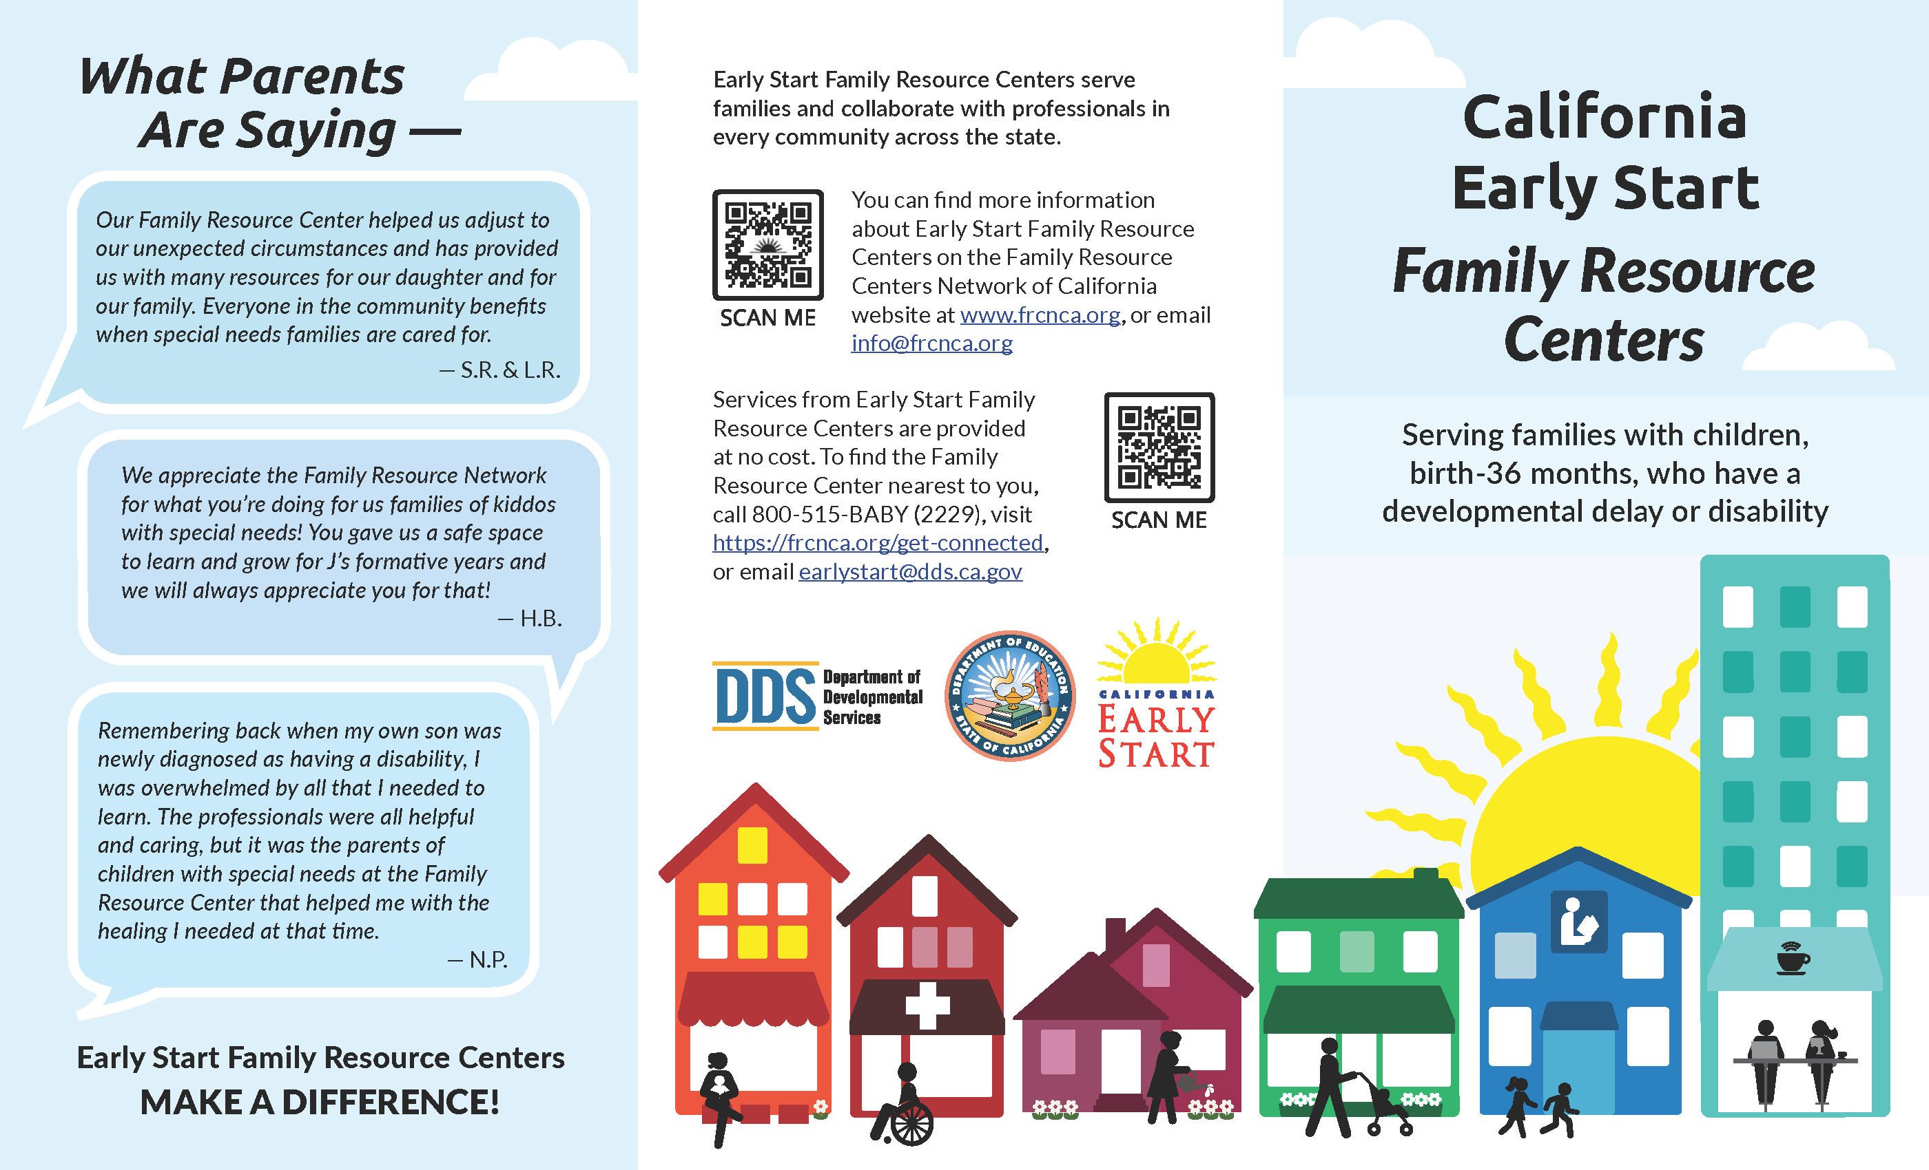
Early Start Family Resource Center Guide

Description: This resource presents information about the Early Start-funded family resource centers within California. It provides links to web pages and online directories with contact information for local Early Start family resource centers.
Format: Legal-sized (8.5 x 14 in.), full-color tri-fold handout with QR codes linking to agency websites to provide viewer with additional information.

Who should receive this resource: Parents and primary caregivers of children eligible or potentially eligible for Early Start.
Where to distribute this resource:
Early Start service coordinators:
- Directly to families during the Early Start intake process
- In outreach packets to primary referral sources (e.g., pediatricians, family practice physicians, childcare providers). Primary referral sources may be found at:
  - Health care facilities
  - Childcare centers
  - Local educational agencies, including school and district offices

Family resource center community outreach personnel:
- Public settings where families of young children may be reached:
- Community resource and information fairs
- Health care waiting rooms
- Childcare centers
- School communal areas
- Other public service office waiting areas (e.g., Social Security, WIC, Unemployment, DMV)
- Libraries, fitness centers, and other public spaces where families may congregate
- Information packets for local and state decision makers when educating them about issues of and services for families of children with or at risk for developmental delays or disabilities

Other Early Start partners:
- As attachments to emails to families
- As a page in a PDF newsletter or other publication
- As a downloadable resource on an agency or community website with other links to Early Start information
Before distributing this resource:
- If printing and folding manually,
  - Print on legal-sized white paper.
  - With page 2 (side showing 3 photos) facing up,
    - Fold right edge in to meet right edge of bottom-left photo (father and infant playing on the floor). “What Parents are Saying—” will be showing.
    - Fold left edge over to cover “What Parents are Saying—” and reveal front of flyer.
Available language versions:
- Printed: English and Spanish
- Downloadable PDF: English, Spanish, Arabic, Russian, and Vietnamese
Click on this link to order either Print or Digital Versions

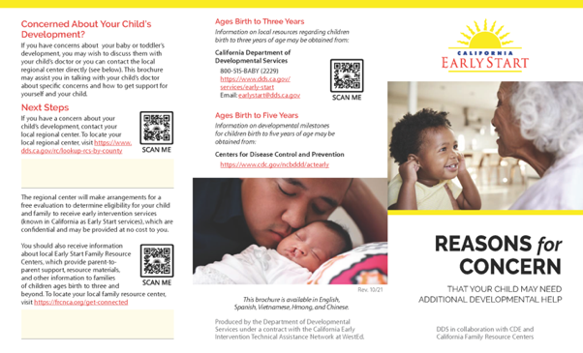
Reasons for Concern Brochure

Description: This resource presents information about risk factors, developmental milestones, and links to agencies that provide Early Start information, supports, and services for families of children with or at risk for developmental delays or disabilities.
Format: Legal-sized (8.5 x 14 in.), full-color tri-fold handout with QR codes linking to agency websites and the Family Resource Centers Network of California.
Who should receive this resource: Parents and caregivers who have questions about the development of a child under the age of three.
Where to distribute this resource:
- Directly to families, accompanied by a discussion and opportunity to ask
questions, during the Early Start intake process
- In outreach packets to primary referral sources (e.g., pediatricians, family
practice, childcare providers). Primary referral sources may be found at:
  - Health care facilities
  - Childcare centers
  - Local educational agencies, including school and district offices
- Other public service agency office waiting areas (e.g., Social Security, WIC, Unemployment, DMV)
- As attachments to emails to families who have questions
- As a downloadable resource on an agency or community website with other links to Early Start information
Before distributing this resource:
- Add local regional center and/or Early Start family resource center contact information to the spaces provided in the left-hand column of page 1 of the PDF:
- Click on the form field in the PDF and type in the agency name, website address, phone number, and/or name of a contact person; or
- Affix a label with the agency name, website address, phone number, and/or contact person’s name in the space provided; or
- Use a pre-made rubber stamp to print the agency name, website address, phone number, and/or contact person’s name in the space provided.

Before distributing this resource:
- If printing and folding manually,
  - Print on legal-sized white paper
  - With page 2 (side without photos) facing up,
1. Fold right edge in to meet right edge of bottom-left photo. “Concerned About Your Child’s Development?” and two QR codes will be showing.
2. Fold left edge over to cover the two QR codes and reveal front of flyer.
Available language versions:
- Printed: English, Spanish, and Chinese (Simplified)
- Downloadable PDF: English, Spanish, Arabic, Chinese (Simplified), Hmong, Korean, Russian, Tagalog, and Vietnamese
Click on this link to order either Print or Digital Versions

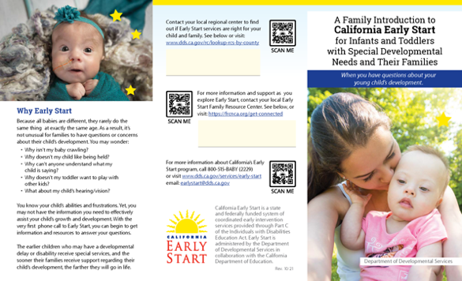
A Family Introduction to California Early Start

Description: This resource presents information about the Early Start program, including a very brief description of the referral, assessment, and planning processes. Links are provided to webpages and online directories for additional information about Early Start.
Format: Legal-sized (8.5 x 14 in.), full-color tri-fold handout with QR codes linking to agency websites to provide viewers with additional information.
Who should receive this resource: Parents and primary caregivers of children eligible or potentially eligible for Early Start.
Where to distribute this resource:
Early Start service coordinators:
- Directly to families during the Early Start intake process
- In outreach packets to primary referrals sources (e.g., pediatricians, family practice physicians, childcare providers)

Family resource center community outreach personnel:
- Public settings where families of young children may be reached:
  - Community resource and information fairs
  - Health care waiting rooms
  - Childcare centers
  - School communal areas
  - Other public service office waiting areas (e.g., Social Security, WIC, Unemployment, DMV)
  - Libraries, fitness centers, and other public spaces where families may congregate
- Information packets for local and state decision makers when educating them about issues of and services for families of young children who have or are at risk for developmental delay or disability

Other Early Start partners:
- As attachments to emails to families
- As a downloadable resource on an agency or community website

Before distributing this resource:
- Add local regional center contact information to the top space and/or local Early Start family resource center to the second space in the middle column on page 1 of the PDF:
  - Click on the form field in the PDF and type in the agency name, contact information, and/or name of a contact person; or
  - Affix a label with the agency name, contact information, and/or contact person’s name in the space provided; or
  - Use a pre-made rubber stamp to print the agency name, contact information, and/or contact person’s name in the space provided.
- If printing and folding manually:
- Print on legal-sized white paper
- With page 2 (side showing 3 steps) facing up,
1. Fold right edge in to meet right edge of bottom-left photo. Baby’s face and “Why Early Start” will be showing.
2. Fold left edge over to cover “Why Early Start” and reveal front of flyer.
Available language versions:
- Printed: Chinese, English, Spanish, and Vietnamese
- Downloadable PDF: English, Spanish, Chinese (Simplified), Arabic, Korean, Russian, and Vietnamese
Click on this link to order either Print or Digital Versions

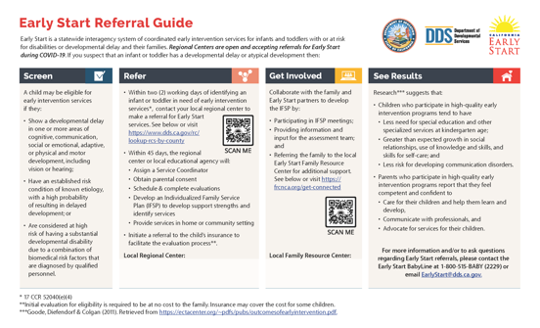
Early Start Referral Guide (Reasons to Refer)

Description: This resource presents information about the screening and referral process for the Early Start program, information on warning signs professionals who work with very young children should look for, and links to webpages and online directories with contact information for local Early Start lead agencies and family resource centers.
Format: Legal-sized (8.5 x 14 in.), a full-color handout with QR codes linking to agency websites for additional program information.
Who should receive this resource: Professionals, especially pediatricians, family practitioners, childcare center directors, childcare providers, etc., who work with and observe the
development of children under the age of three.
Where to distribute this resource:
- Hospitals, including prenatal and postnatal care facilities
- Physicians’ offices and health care clinics, both private and public facilities
- Childcare resource and referral (R&R) agencies
- Childcare settings
- Social service agencies frequented by families
Before distributing this resource:
- Add regional center contact information to the space in the “Refer” column and/or local family resource center contact information to the space in the “Get Involved” column:
- Click on the form field in the PDF and type in the agency name, contact information, and/or the name of a contact person; or
- Affix a label with the agency name, contact information, and/or contact person’s name in the space provided; or
- Use a pre-made rubber stamp to print the agency name, website address, phone number, and/or contact person’s name in the space provided.
Available language versions:
- Printed: English and Spanish
- Downloadable PDF: English, Spanish, Chinese (Simplified), Armenian, Farsi, Hmong, Korean, Tagalog, and Vietnamese
Click on this link to order either Print or Digital Versions

“The Story of Max” Animated Video

Description: The Story of Max is a guide to the California Early Start system through the lens of a family. It places the viewer in the shoes of parents who have concerns about their child’s development and follows them from referral to IFSP and the start of services.
Format: 3-minute, animated video
Who should receive this resource: Parents whose child has been identified, and parents who are interested in learning about the Early Start intake and planning process.
Where to distribute this resource:
- Agency websites
- Agency social media pages or postings, including Facebook and Twitter
- Community events or presentations where the video may be played on a laptop
How to distribute this resource:
- To embed the video:
  - Choose the HTML editing tool on the web page, post, or section. It usually opens through an icon that looks like this: <>
  - Find the spot in the HTML code where the video will be placed.
  - Copy the code after the version colon below:
    - For English version: <div style=”padding:56.25% 0 0 0;position:relative;”><iframe src=”https://player.vimeo.com/video/618197694?h=fe82248d10&amp;badge=0&amp;autopause=0&amp;player_id=0&amp;app_id=58479” frameborder=”0” allow=”autoplay; fullscreen; picture-in-picture” allowfullscreen style=”position:absolute;top:0;left:0;width:100%;height:100%;” title=”The Story of Max”></iframe></div><script src=”https://player.vimeo.com/api/player.js”></script>
    - For the Spanish version: <div style="padding:56.25% 0 0 0;position:relative;"><iframe src="https://player.vimeo.com/video/618208826?h=69b375e33c&amp;badge=0&amp;autopause=0&amp;player_id=0&amp;app_id=58479" frameborder="0" allow="autoplay; fullscreen; picture-in-picture" allowfullscreen style="position:absolute;top:0;left:0;width:100%;height:100%;" title="La Historia de Max"></iframe></div><script src="https://player.vimeo.com/api/player.js"></script>

- To download the video or to share on various social media platforms,
  - Use the links below to navigate to Vimeo, where the videos are stored.
  - Click on the 3 dots on the upper right of the screen, next to the Embed button. 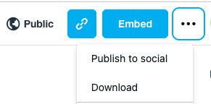
  - Choose “Publish to social” or “Download” and follow the onscreen prompts.
Links to available language versions:
- English
- Spanish

Early Start Public Service Announcement (PSA) Videos

Description: These public service announcements (PSA) describe how the first three years of a child’s life are critical to their overall development. The videos list some developmental skills to look for and describe how to request information about Early Start through an 800 number if a parent has questions or concerns about a child’s development. The PSA is available in two versions:
      - Former Surgeon General’s Message: Dr. Nadine Burke Harris delivers the message.
      - Parents Give Advice: Parents of children who have received Early Start services deliver the message.
Format: 2-minute videos, with closed captions/subtitles in English and Spanish
Who should receive this resource: Parents and caregivers who may observe developmental delays or have questions about the development of infants and toddlers in their care.
Where to distribute this resource:
- Agency websites
- Agency social media pages or postings, including Facebook and Twitter
- Community events or presentations where the video may be played on a laptop
- Local television stations as a public service announcement
How to distribute this resource:
- To embed the video:
  - Choose the HTML editing tool on the web page, post, or section. It usually opens through an icon that looks like this: <>
  - Find the spot in the HTML code where the video will be placed.
  - Copy the code after the version colon:
  - Former Surgeon General’s Message: <div style="padding:56.25% 0 0 0;position:relative;"><iframe src="https://player.vimeo.com/video/514553837?h=6fbb57e541&amp;badge=0&amp;autopause=0&amp;player_id=0&amp;app_id=58479" frameborder="0" allow="autoplay; fullscreen; picture-in-picture" allowfullscreen style="position:absolute;top:0;left:0;width:100%;height:100%;" title="Former Surgeon General&amp;#039;s Message."></iframe></div><script src="https://player.vimeo.com/api/player.js"></script>
  - Parents Give Advice: <iframe src="https://player.vimeo.com/video/567719100?h=37f666a5bd" width="640" height="360" frameborder="0" allow="autoplay; fullscreen; picture-in-picture" allowfullscreen></iframe>

- To download the video or to share on various social media platforms,
  - Use the links below to navigate to Vimeo, where the videos are stored.
  - Click on the 3 dots on the upper right of the screen, next to the Embed button.
  - Choose “Publish to social” or “Download” and follow the onscreen prompts.
Links to videos:
- Former Surgeon General's Message
- Parents Give Advice video

Additional Resources

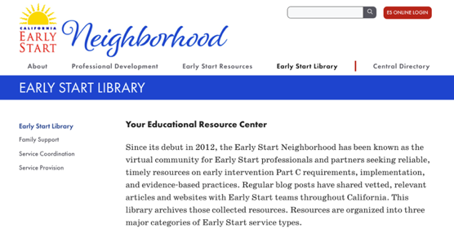
Neighborhood Blog Posts

Description: The Early Start Neighborhood is a virtual community for Early Start professionals and partners seeking training, technical assistance, and resources on early intervention Part C requirements, implementation, and evidence-based practices. One feature of the Neighborhood is the bi-weekly blog, highlighting research and resources specifically curated for their relevance to the Early Start community.

Format: Links to websites and online resources from trusted sources, including federal and state agencies, national technical assistance centers, and established professional organizations focusing on services for very young children and their families.
Who should receive these resources: Depending on the blog post,
- Colleagues and community partners who work with very young children and their families
- Parents and caregivers of infants and toddlers
How to share these resources:
- To share with colleagues and community partners:
  - Forward the Neighborhood update email with the original blog post.
  - Review recent blog posts during staff or community meetings.
  - Share the Neighborhood URL (earlystartneighborhood.ning.com) and encourage staff and community partners to sign up to receive blog posts.
  - Add a Neighborhood Facebook or Twitter feed to a website.
- To share with parents and caregivers:
  - Forward the email with the original blog post.
  - Review recent blog posts during home visits.
  - Review recent blog posts during parent support group meetings.
  - Share the Neighborhood URL (earlystartneighborhood.ning.com) and encourage parents and caregivers to follow the blog page to receive notifications about recent posts.
  - Add research and resources from blog posts to program newsletters.

Calendar of Awareness Campaigns

Many programs and associations have established specific and recurring time periods in which they promote awareness of a cause, condition, or group of children or families. The awareness campaigns typically last for an entire month but some may be implemented during a specific week or on a special day. Below are two lists of campaigns: 1) Campaigns listed by month and 2) Campaigns listed alphabetically by focus with time periods noted.

Awareness Calendar by Month:

June:
Aphasia Awareness Month
National Congenital CMV Awareness Month
Scleroderma Awareness Month
June 12th – International Children’s Day
June 24th – Helen Keller Deafblind Awareness Week
PTSD Awareness Day

July:
National Fragile X Awareness Month
National Cleft and Craniofacial Awareness and Prevention Month
July 22nd - National Fragile X Awareness Day

August:
Children’s Eye Health and Safety Month
Gastroparesis Awareness Month
Spinal Muscular Atrophy Awareness Month
August 7th – World PVNH Disorder Awareness Day

September:
Baby Safety Month
Hydrocephalus Awareness Month
Newborn Screening Awareness Month
Reye’s Syndrome Awareness Month
Traumatic Brain Injury Awareness Month
National Rehabilitation Awareness Celebration (3rd week of Sept)
September 25th – International Ataxia Awareness Day

October:
Blindness Awareness Month
National Down Syndrome Awareness Month
Learning Disabilities Awareness Month
Physical Therapy Month
Rett Syndrome Awareness Month
Sensory Awareness Month
October 2nd – Child Health Day
October 5th – World Cerebral Palsy Day
October 13th – World Sight Day

November:
Epilepsy Awareness Month
Family Caregivers Month
Prematurity Awareness Month
November 7th – World Prematurity Day
November 20th – Universal Children’s Day

December:
Safe Toys and Gifts Month
December 2nd – Special Education Day
December 3rd – International Day of Persons with Disabilities

January:
National Birth Defects Awareness Month
January 4th – World Braille Day
January 24th – Moebius Syndrome Awareness Day

February:
AMD/Low Vision Awareness Month
Children’s Dental Health Month
Feeding Tube Awareness Week
Marfan Awareness Month
February 13th – Duchenne Muscular Dystrophy Awareness Week
February 15th – International Angelman Day
February 28th – Rare Disease Day

March:
Cerebral Palsy Awareness Month
Developmental Disabilities Awareness Month
Multiple Sclerosis Awareness Month
Trisomy Awareness Month
Spread the Word to End the Word Day
March 21st – World Down Syndrome Day
March 25th – Cerebral Palsy Awareness Day
March 26th – Purple Day for Epilepsy Awareness

April:
Autism Awareness Month
Occupational Therapy Month
Stress Awareness Month
April 2nd – World Autism Awareness Day

May:
Better Hearing and Speech Month
Prader-Will Syndrome Awareness Month
Williams Syndrome Awareness Month
May 4th - National Childhood Stroke Awareness Day
May 13th – Cornelia de Lange Syndrome Awareness Day

Awareness Campaigns (Alphabetically)

-A-
AMD/Low Vision Awareness Month (February)
Asphasia Awareness Month (June)
Autism Awareness Month (April)

-B-
Baby Safety Month (September)
Better Hearing and Speech Month (May)
Birth Defects Awareness Month (January)
Blindness Awareness Month (October)

-C-
Cerebral Palsy Awareness Day (March 25th)
Cerebral Palsy Awareness Month (March)
Children’s Dental Health Month (February)
Children’s Eye Health and Safety Month (August)
Child Health Day (October 2nd)
Cornelia de Lange Syndrome Awareness Day (May 13th)

-D-
Deafblind Awareness Week (Helen Keller) (June 24th)
Developmental Disabilities Awareness Month (March)
Down Syndrome Awareness Month (October)
Duchenne Muscular Dystrophy Awareness Week (February 13th)

-E-
Epilepsy Awareness Month (November)
Epilepsy Awareness (Purple Day) (March 26th)

-F-
Family Caregivers Month (November)
Feeding Tube Awareness Week (February 6-10th, 2023)
Fragile X (National) Awareness Day (July 22nd)
Fragile X Awareness Month (July)

-G-
Gastroparesis Awareness Month (August)

-H-
Hydrocephalus Awareness Month (September)

-I-
International Angelman Day (February 15th)
International Children’s Day (June 12th)
International Ataxia Awareness Day (September 25th)
International Day of Persons with Disabilities (December 3rd)

-L-
Learning Disabilities Awareness Month (October)

-M-
Marfan Awareness Month (February)
Moebius Syndrome Awareness Day (January 24th)
Multiple Sclerosis Awareness Month (March)

-N-
National Childhood Stroke Awareness Day (May 4th)
National Cleft and Craniofacial Awareness and Prevention Month (July)
National Congenital CMV Awareness Month
National Rehabilitation Awareness Celebration (3rd week of September)
Newborn Screening Awareness Month (September)

-O-
Occupational Therapy Month (April)

-P-
Physical Therapy Month (October)
Prader-Will Syndrome Awareness Month (May)
Prematurity Awareness Month (November)
PTSD Awareness Day (June)

-R-
Rare Disease Day (February 28th)
Rett Syndrome Awareness Month (October)
Reye’s Syndrome (September)

-S-
Safe Toys and Gifts Month (December)
Scleroderma Awareness Month (June)
Sensory Awareness Month (October)
Special Education Day (December 2nd)
Spinal Muscular Atrophy Awareness Month (August)
Stress Awareness Month (April)

-T-
Traumatic Brain Injury Awareness Month (September)
Trisomy Awareness Month (March)

-U-
Universal Children’s Day (November 20th)

-W-
Williams Syndrome Awareness Month (May)
World Autism Awareness Day (April 2nd)
World Braille Day (January 4th)
World Cerebral Palsy Day (October 5th)
World Down Syndrome Day (March 21st)
World Prematurity Day (November 7th)
World PVNH Disorder Awareness Day (August 7th)
World Sight Day (October 13th)

Contact Information

The Early Start Resources that appear in this Toolkit have been produced by WestEd under the Comprehensive System of Personnel Development and Resources (CSPD-R) contract, from the California Department of Developmental Services (DDS).
- To download or order resources, visit the website at https://earlystartneighborhood.org/resources/resources-for-outreach-child-find-and-education/outreach-and-child-find-materials/
- To correspond about resources, email esorders@wested.org
- For additional resources, visit the DDS Early Start website at https://www.dds.ca.gov/services/early-start/early-start-publications-resources-and-program-guidance/
- Social media outlets:
  - Facebook - California Early Start Neighborhood page at https://www.facebook.com/California-Early-Start-Neighborhood-108543204810411
  - Twitter - The Early Start Neighborhood at https://twitter.com/esneighbors

